C5_4

setwd(".")  
library(knitr)

Apartado a)

#P(X > 1)  
n <- 35  
p <- 0.05  
PA <- 1-pbinom(1,n,p)  
x <- seq(1,50,1)  
y35 <-1-pbinom(x,n,p)

Apartado b)

#P(X > 10)  
n2 <- 500  
p2 <- 0.05  
PB <-1-pbinom(9,n2,p2)  
y500 <-1-pbinom(x,n2,p2)

Visualizacion

plot(x,y35, type="l", col="orange",main = "Probabilidades",ylab = "Probabilidades", ylim = c(0, max(y500)))  
points(x,y500,type = "l",col="blue")  
grid()

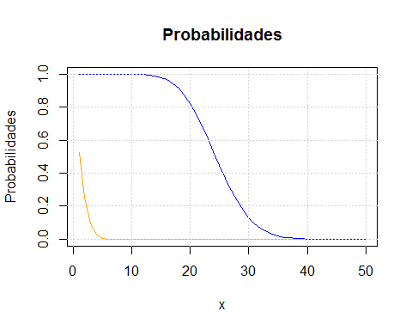

Conclusiones